**ECO 304K Exam 3 Spring 2024 (11am)**

**Version: AC**

**Last Name: __________________**

**First Name: __________________**

**UT ID: __________________**

**Directions:** There are 40 questions on this exam. Each question is worth the same (1 point). You also **MUST SKIP 3** questions, which are automatically counted correct. For each multiple-choice question, select the best response. For each short answer question, you can earn 1/2 credit if your answer is incorrect, but you explain your reasoning/show your work. This is a closed book, closed notes exam. You may use a physical calculator but may not use a cell phone or any other electronic device during the exam. Make sure you write your full name and UT ID above. Hand in your exam and show your student ID to the TA when turning in your exam. Good luck!

**\*\*\*Write the word SKIP next to three questions\*\*\***

**Multiple-Choice Answers: Short Answers:**

**1. ________ 17. ________ 33. ____________**

**2. ________ 18. ________ 34. $____________**

**3. ________ 19. ________ 35. $____________**

**4. ________ 20. ________ 36.** GDP: **____________**

**5. ________ 21. ________** Unemployment: **__________**

**6. ________ 22. ________** Price Level: **__________**

**7. ________ 23. ________ 37. Circle one choice**

**8. ________ 24. ________** Y1

**9. ________ 25. ________** Y2

**10. ________ 26. ________** Y3

**11. ________ 27. ________ 38. $___________**

**12. ________ 28. ________ 39. Russia’s opp cost: __________**

**13. ________ 29. ________ 40. _______ cars**

**14. ________ 30. ________ _______ tons of paper**

**15. ________ 31. ________**

**16. ________ 32. ________**

**For Graders**

**Correct SA: ____ + Partial Credit: ____ x 1/2 ____ = Total SA Points: ____**

**TOTAL POINTS: MC: _____ + SA: _____ + 3 SKIPS = /40**

**1. During which of the following situations would the government most likely have a contractionary fiscal policy?**

A) When the volume of imports is unusually low.

B) When the economy is in the upswing phase of a business cycle.

C) When the inflation rate is running unusually high.

D) When the unemployment rate is running unusually high.

**2. During a recession, unemployment will ______, tax revenue collected by the government will ______, and transfer payments paid by the government will _______.**

A) decrease; decrease; increase

B) decrease; increase; decrease

C) increase; increase; decrease

D) increase; decrease; increase

**3. An impact lag happens because:**

A) it takes time for the effects of monetary and fiscal policy to materialize.

B) the effects of recessions are felt sooner than the effects of expansions.

C) it is difficult to determine when the economy is turning up or down.

D) in most nations, one or more governing bodies must approve government spending or new tax policies.

**4. Supply-side fiscal policy initiatives take a long time to shift the aggregate supply curve to the right. As a result, supply-side proposals:**

A) are generally emphasized as short-run solutions to growth problems.

B) are generally emphasized as long-run solutions to growth problems.

C) are regarded as a waste of time.

D) have no short-run benefits.

**5. When aggregate demand is low enough to drive unemployment above the natural rate:**

A) there is downward pressure on the price level, and the government may want to institute a contractionary fiscal policy.

B) the economy is entering into an expansion, and the government may want to institute a contractionary fiscal policy.

C) there is upward pressure on the price level, and the government may want to institute a contractionary fiscal policy.

D) there is downward pressure on the price level, and the government may want to institute an expansionary fiscal policy.

**Refer to the following graph to answer the next question.**

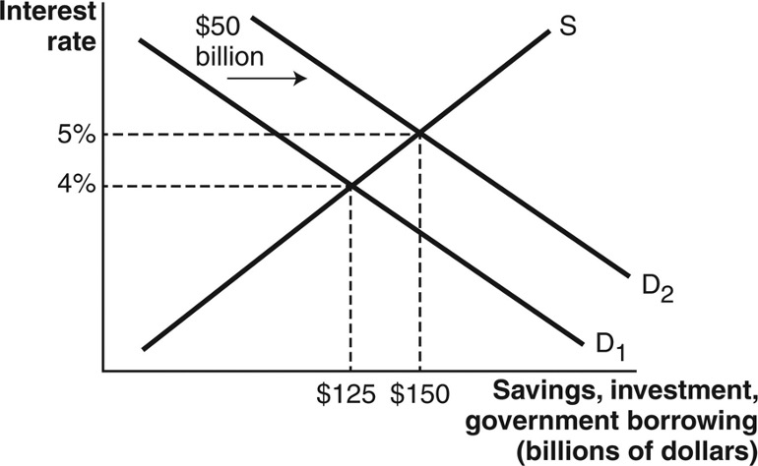

**6. According to the graph, the amount of private investment after government borrowing of $50 billion is ________ billion.**

A) $100

B) $150

C) $175

D) $200

**7. Assume that the government is currently balancing the national budget so that outlays equal tax revenues. Then the economy starts to expand, and the government decides to decrease government spending by $50 billion. As a result, the federal budget will:**

A) be in deficit by at least $50 billion.

B) be in surplus by at least $50 billion.

C) remain balanced.

D) be in surplus by less than $50 billion.

**8. What function of money is highlighted when Sheila buys her boyfriend a paintball gun for their three-month anniversary?**

A) Liquidity.

B) Unit of account.

C) Store of value.

D) Medium of exchange.

**9. The statement: “My savings account indicates that I have $2.34” represents money as:**

A) a medium of exchange.

B) a store of value.

C) liquidity.

D) a unit of account.

**10. Which of the following is NOT a characteristic of fiat money?**

A) Generally acceptable as a medium of exchange.

B) Provides a way to store wealth over time.

C) Serves as a unit of account.

D) Always backed by something of high intrinsic value.

**11. What boundary did the U.S. Federal Reserve hit with quantitative easing in 2008, which forced it to look for other policy tools?**

A) Short-term interest rates were at 0%.

B) Banks stopped respecting the reserve requirement.

C) Banks stopped keeping reserves on deposit with the Federal Reserve.

D) The market demand for Treasury bonds shifted.

**12. What move by the Federal Reserve (Fed) in 2008 reduced banks’ opportunity cost of holding excess reserves?**

A) The Federal Reserve started paying interest on bank reserves deposited with the Fed.

B) The Federal Reserve lowered the required reserve ratio and with it the required size of reserves.

C) The Federal Reserve made it easier for banks to lend reserves on deposit at the Fed to other banks.

D) The Federal Reserve made it illegal for banks to keep excess reserves in their own vaults.

**13. Federal Deposit Insurance (FDIC) creates a moral hazard problem in the banking system.**

A) True.

B) False

**14. Which of the following best describes how expansionary monetary policy affects the aggregate demand curve in the aggregate demand–aggregate supply model?**

A) Expansionary monetary policy directly pulls money out of the loanable funds market. This lowers the interest rate, which provides a larger incentive for firms to invest. Investment is a component of aggregate demand, so this shifts aggregate demand to the right.

B) Expansionary monetary policy directly puts money into the loanable funds market. This lowers the interest rate, which provides a larger incentive for firms to invest. Investment is a component of aggregate demand, so this shifts aggregate demand to the right.

C) Expansionary monetary policy directly puts money into the loanable funds market. This raises the interest rate, which provides a larger incentive for firms to invest. Investment is a component of aggregate demand, so this shifts aggregate demand to the right.

D) Expansionary monetary policy directly puts money into the loanable funds market. This lowers the interest rate, which provides a larger incentive for firms to invest. Investment is a component of aggregate demand, so this shifts aggregate demand to the left.

**15. Which scenario is most consistent with an increase in aggregate demand and, simultaneously, a comparable decrease in short-run aggregate supply, due to anticipated expansionary monetary policy?**

A) The price level remains the same and real gross domestic product (GDP) decreases.

B) The price level increases, and real GDP decreases.

C) The price level increases, and real GDP remains the same.

D) The price level decreases, and real GDP remains the same.

**16. If inflation is expected, prices will not be sticky.**

A) True.

B) False.

**17. Which of the following did the Federal Reserve not do in response to COVID-19?**

A) Lower the discount rate to nearly zero.

B) Suspend all reserve requirements.

C) Lower short-term interest rates.

D) Sell huge amounts of mortgage-based securities.

**18. If an increase in the quantity of money leads to real growth in the economy, why would the central bank ever stop increasing the money supply?**

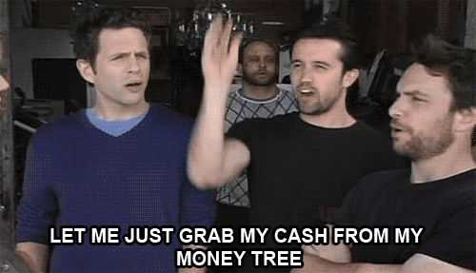

A) Although there is a short-run incentive to increase the money supply, these effects wear off in the long run as prices adjust and then drive up the value of money.

B) In the long run, uninterrupted economic growth eventually leads to rising unemployment.

C) Increasing the money supply only leads to growth when the policy is unexpected. When it is predictable, it just drives down the value of money.

D) Increasing the money supply is not a politically popular action and may lead to leaders of the central bank not getting re-elected.

**19. Which of the following groups are hurt if inflation is higher than expected?**

A) Input suppliers that have sticky prices.

B) Workers who signed wage contracts.

C) Someone who borrowed money at a fixed rate.

D) Two of the above answers are correct.

***Use the following scenario to answer questions 20-22.***

***Two small countries, Paul and Tim produce two goods: fish and coconuts. Paul can produce 60 fish per hour or 20 coconuts per hour. Tim can produce 30 fish per hour or 40 coconuts per hour. Both countries experience constant opportunity costs.***

**20. Based on the scenario, which of the following will happen with trade?**

A) Paul has a comparative advantage in fish.

B) Paul has a comparative advantage in coconuts.

C) Tim has a comparative advantage in fish.

D) There are no potential gains from trade because the opportunity costs of both goods are identical for both countries.

**21. Based on the scenario, which of the following is true?**

A) Paul’s opportunity cost of a coconut is three fish.

B) Tim’s opportunity cost of a coconut is one fish.

C) Paul’s opportunity cost of a fish is one-third of a coconut.

D) Both A and C are correct.

**22. Based on the scenario, which of the following will most likely occur if these two countries engage in trade with each other?**

A) Total joint output per hour will be 60 coconuts and 90 fish.

B) Total joint output per hour will be 40 coconuts and 60 fish.

C) Total joint output per hour will be 20 coconuts and 30 fish.

D) Total joint output per hour will be 30 coconuts and 45 fish.

**23. An example of a voluntary quota is:**

A) Venezuela charging an additional 20% tax on oil imported from Iran.

B) a decision by the United Kingdom to limit Malaysian shoe imports to 250,000 per year.

C) South Korean electronics manufacturers agreeing to limit exports to New Zealand.

D) France charging an additional 10% tax on imports of Vietnamese clothing.

**24. In the domestic market following the imposition of an import quota, imports _____, domestic production _____, and prices _____.**

A) decrease; increases; decrease

B) increase; increases; increase

C) decrease; increases; increase

D) increase; decreases; decrease

**25. Suppose that the U.S. dollar appreciates against the Japanese Yen. What will happen as a result?**

A) The exchange rate of yen to dollars will not change.

B) Japanese goods will become more attractive to American consumers.

C) It will take less yen to buy a U.S. dollar.

D) It will take more U.S. dollars to buy yen.

**26. The national government or central bank of a country might take steps to purposefully depreciate its currency:**

A) to be able to sell more goods to consumers in other countries.

B) to enable its producers to buy more goods from other countries.

C) to harm producers and consumers in other countries.

D) to reduce costs for its producers.

**27. If the U.S. current account is in deficit, the U.S. capital account is in surplus.**

A) True

B) False.

**28. Suppose an American citizen purchases a TV from Sony (a Japanese company). Sony then uses the dollars to purchase U.S. Treasury bonds. How will this transaction impact the U.S. trade deficit?**

A) The transaction is recorded as an export in the current account, so the trade deficit will increase.

B) The transaction is recorded as an import in the current account, so the trade deficit will increase.

C) The transaction is recorded as an export in the current account, so the trade deficit will decrease.

D) The transaction is recorded as an import in the current account, so the trade deficit will decrease.

**Use these graphs to answer the next question.**

**The following two graphs depict the demand and supply of U.S. dollars and the demand and supply of British pounds in the foreign currency exchange market.**

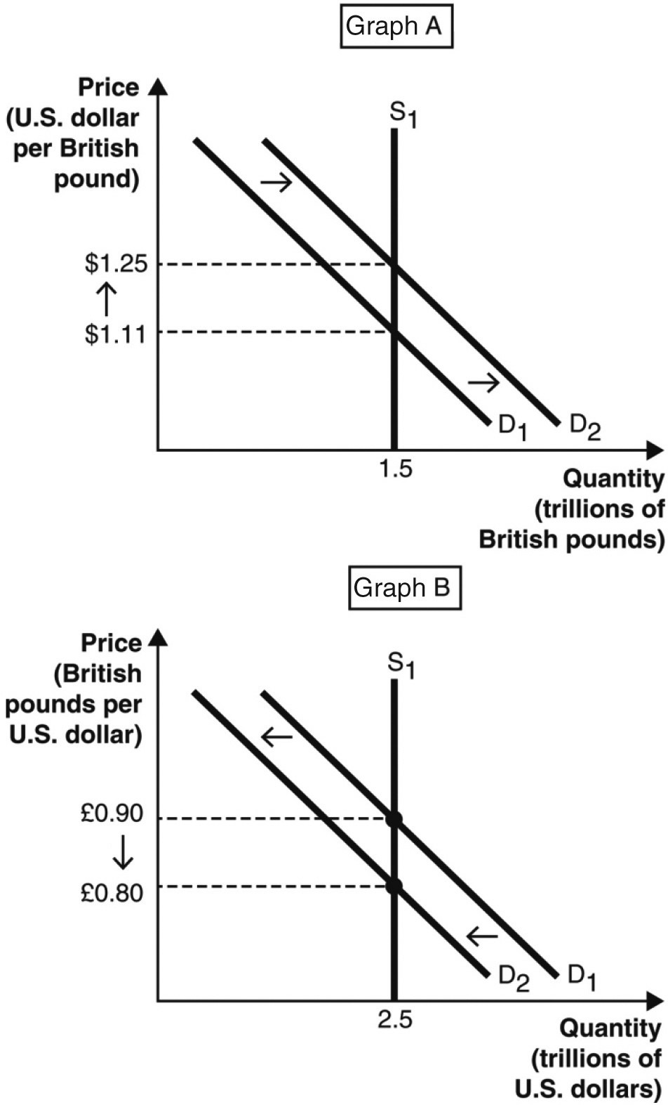

**29. An appreciation of the ________ is shown in ________.**

A) U.S. dollar; Graph B but not Graph A

B) U.S. dollar; both Graphs A and B

C) British pound; neither Graph A nor Graph B

D) British pound; both Graphs A and B

***Use the table to answer the next question.***

***The following table shows the number of U.S. dollars required to buy one Mexican peso between August 1, 2023 and November 1, 2023.***

|  |  |
| --- | --- |
| **Date** | **U.S. Dollars Required to Buy 1 Mexican Peso** |
| August 1, 2023 | 0.05221 |
| September 1, 2023 | 0.04985 |
| October 1, 2023 | 0.05067 |
| November 1, 2023 | 0.05198 |

**30. Between September 1, 2023 and October 1, 2023, the number of U.S. goods exported to Mexico likely:**

A) increased because U.S. goods became more expensive to consumers in Mexico.

B) decreased because U.S. goods became more expensive to consumers in Mexico.

C) increased because U.S. goods became less expensive to consumers in Mexico.

D) decreased because U.S. goods became less expensive to consumers in Mexico.

**31. How can domestic savings rates cause a current account deficit?**

A) High domestic savings rates fuel import purchases.

B) High domestic savings rates fuel export purchases.

C) Lower domestic savings rates mean that foreign investment is needed to fund domestic investment.

D) Higher domestic savings rates increase government budget deficits.

**Use these graphs to answer the next question.**

**The following two graphs depict the equilibrium price of a pound of Kentucky flax seed sold in Kentucky and West Virginia, respectively. Assume the type and quality of the flax seed being sold in the two states are identical. Further, assume flax seed sellers incur zero costs to transport flax seed between the two states and that there are no other barriers to trade.**

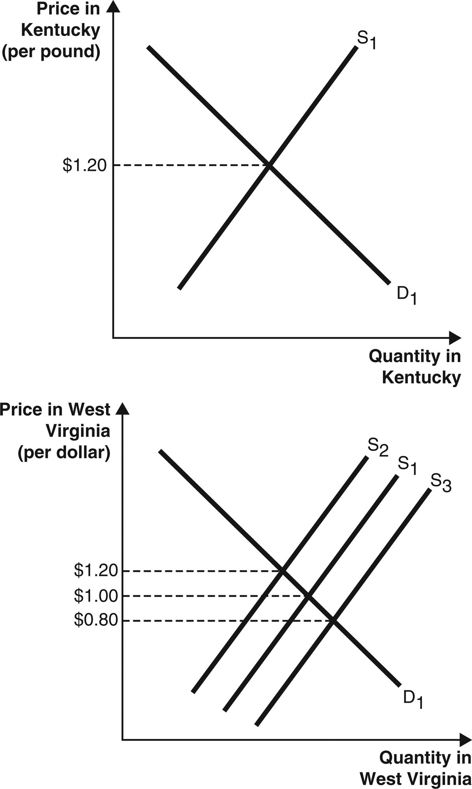

**32. Suppose the price of a pound of Kentucky flax seed is currently $1.20 in Kentucky and $1.00 in West Virginia. In this case, sellers will have an incentive to sell their flax seed in ________. Thus, the supply of flax seed in Kentucky will ________ and the supply in West Virginia will ________.**

A) Kentucky; increase; decrease

B) Kentucky; decrease; increase

C) West Virginia; increase; decrease

D) West Virginia; decrease; increase

**Enter your answers for the short answer section on the Answer (front) page.**

**33. If the spending multiplier is 5, the marginal propensity to consume (MPC) is _____.**

**Refer to the following graph to answer the next question, where LRAS is long-run aggregate supply, SRAS is short-run aggregate supply, and AD is aggregate demand.**

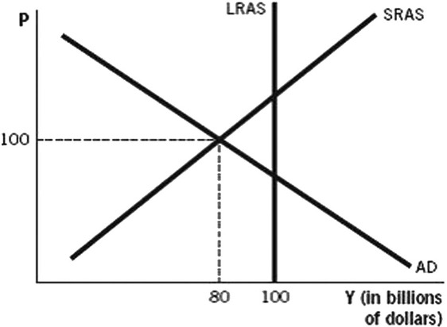

**34. According to the graph above, and assuming the marginal propensity to consume is 0.9, to shift aggregate demand back to the long-run equilibrium, the government would have to increase government spending by: ______**

**35. If banks have a required reserve ratio of 20%, and one bank is currently holding $8,000 in excess reserves, the maximum impact on the money supply if the bank loans out all of the excess reserves will be ______**

**36. In the short run, expansionary monetary policy _______________ real gross domestic product (GDP), _______________ unemployment, and _______________ the price level.**

**On the front page, write “raises”, “lowers” or “does no change” for each variable.**

**37. According to the graph, if a contractionary monetary policy is fully expected, and the economy starts initially in full-employment equilibrium, in the long run the real GDP will be _____.**

**On the front page, circle Y1, Y2, or Y3.**

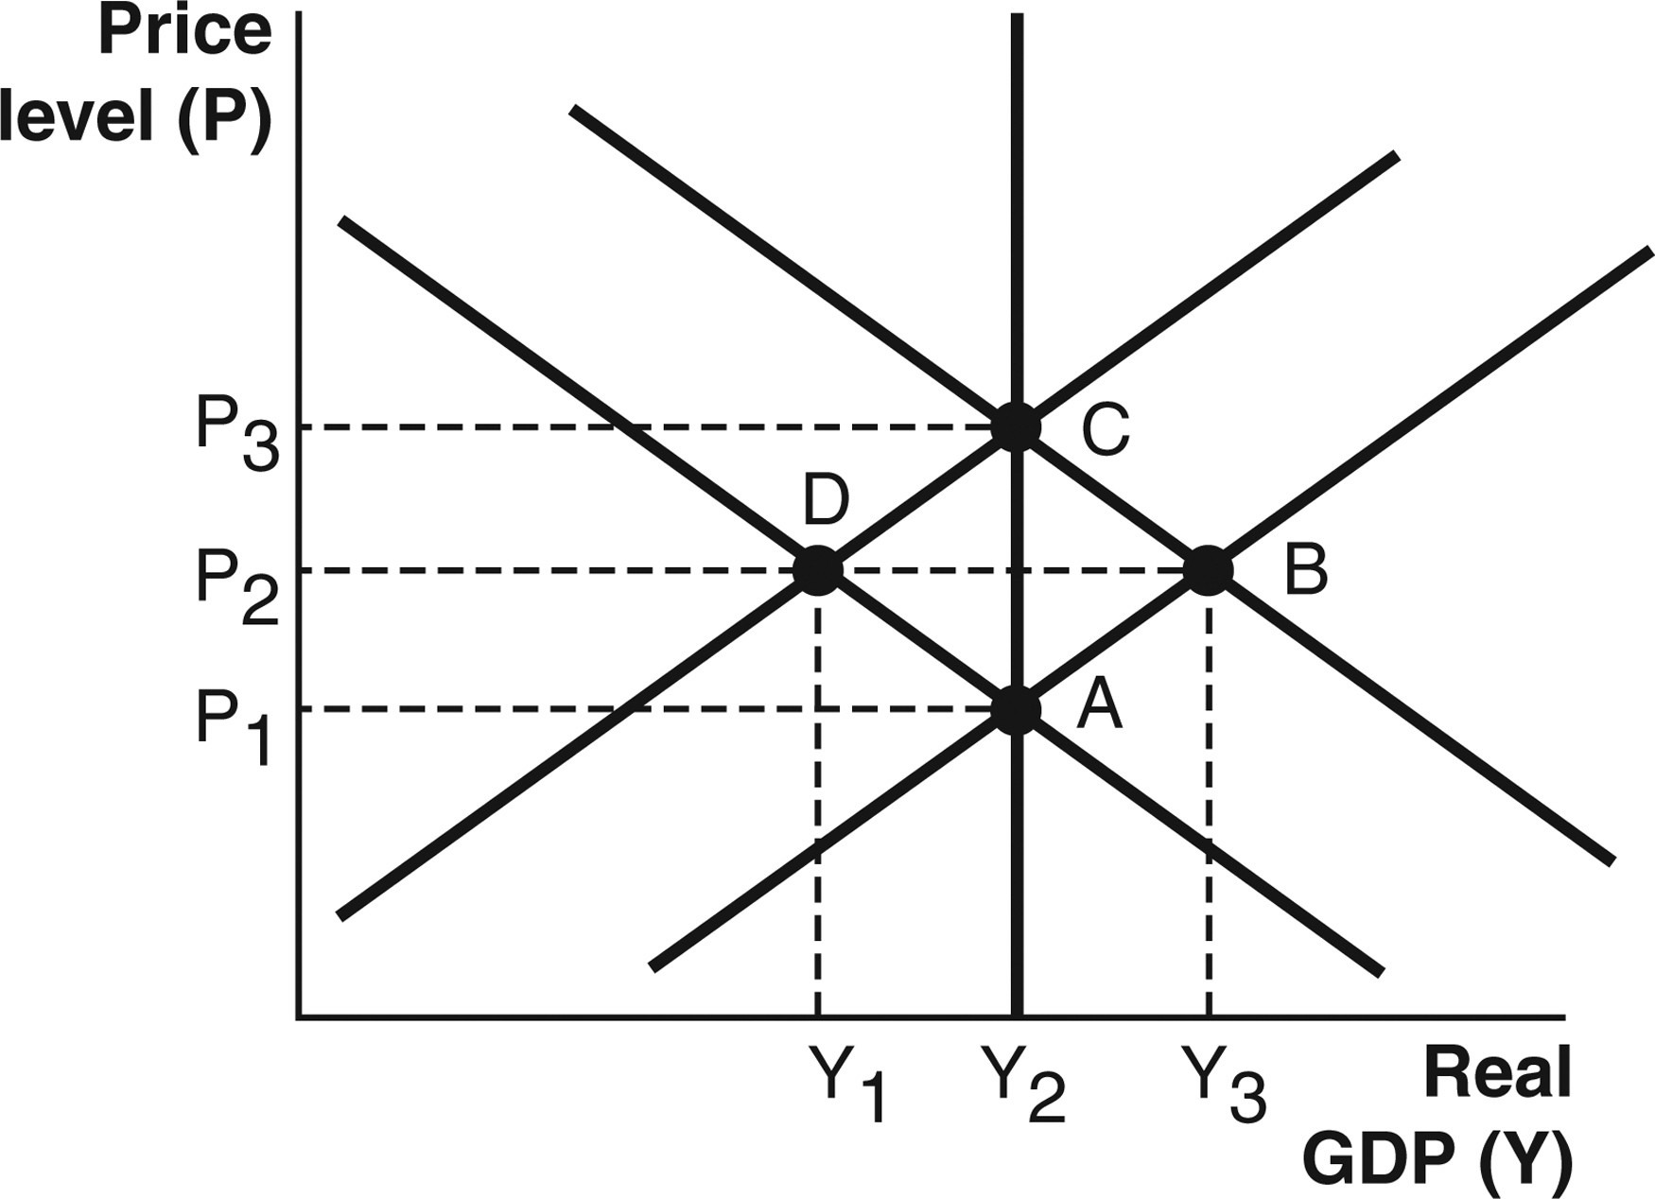

**38. Assuming the theory of purchasing power parity holds, if the exchange rate between the United States and Europe is $1.12 per euro, then how much does a 50 Euro bottle of French champagne cost in U.S. dollars?**

**The following graph illustrates the production possibilities for two countries, Russia and Canada.** **Please use this graph to answer questions 39-40.**

**Assume that initially, the two countries do not trade. Russia produces 40 cars and 5 tons of paper. Canada produces 16 cars and 42 tons of paper. You can assume cars and paper are measured in thousands of units.**

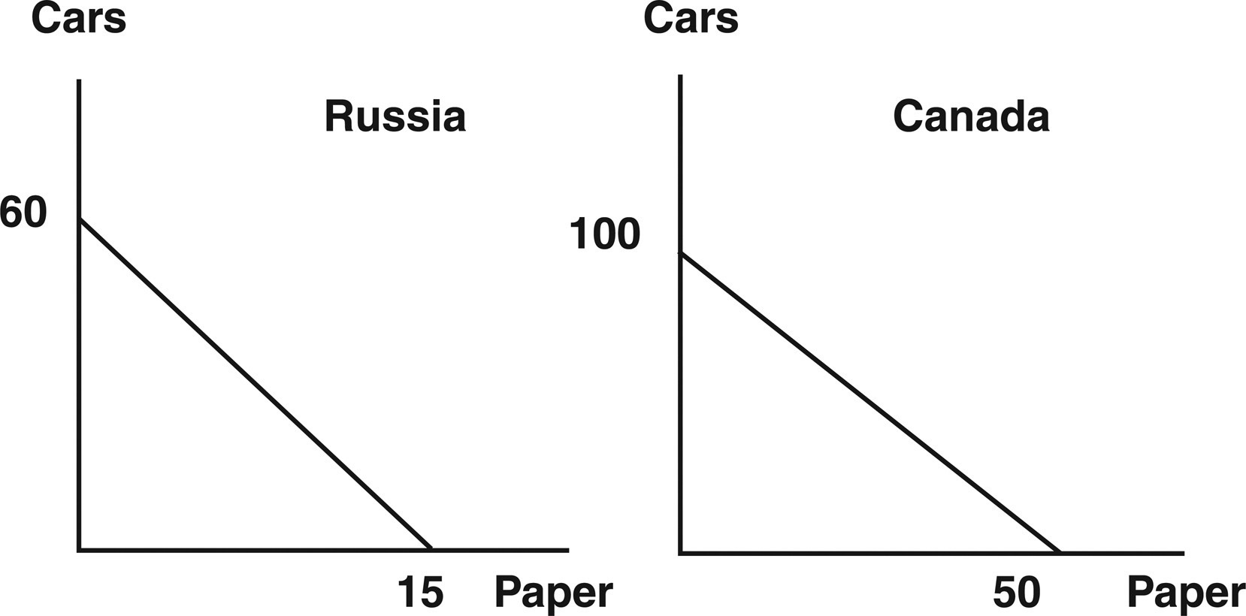

**39. What is Russia’s opportunity cost of producing 1 ton of paper?**

**40. Suppose the two countries decide to completely specialize and trade. If they decide to trade 18 cars in exchange for 6 tons of paper, then after trade, Russia will be able to consume ________ cars and ________ tons of paper.**